Unit 4 Don’t eat in class.
Ⅰ.你知道吗？
Are there any rules in your school? What are they?
●
●
●
●
●
Ⅱ.根据句意，用can和can’t填空
1.Mr Green smoke here, because there’s a sign on the wall. It says\!No smoking.”
2.It’s very hot outside. You wear a hat.
3.We eat in the classroom, because it’s impolite to teachers.
4.I go to bed after 11:00 on school night.
5.The students read books and magazines in the library.
Ⅲ.用have to或has to填空
1.We clean our classroom after school.
2.She make her bed after getting up.
3.It’s late. Mr. Beckman go to work by car.
4.Emily and Peter join a music club. They practice guitar every day.
Ⅳ.看图完成对话
A :Do you have a library at school?
B: Yes, we do. And we have for school library.
A: What are they?
B: We have to keep quiet in the .We have put our umbrella the library .We can’t , or listen to the music in it.
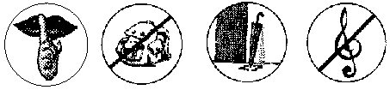

附参考答案：
Ⅰ.略
Ⅱ.1.can’t 2.can 3.can’t 4.can’t 5.can
Ⅲ.1.have to 2.has to 3.has to 4.have to
Ⅳ.rules, library, outside, talk, eat

